

Lab Experiment – 09
Travelling Salesman Problem (TSP)

Aim
To implement the Travelling Salesman Problem (TSP) using Python.

Objective
To find the minimum-cost route that visits every city exactly once and returns to the starting city.

Algorithm
- Start with a set of cities and their distances.
- Select a starting city.
- Generate all possible routes through the remaining cities.
- Calculate the total distance of each route.
- Add the distance from the last city back to the starting city.
- Compare the total distances.
- Select the route having the minimum distance.
- Display the shortest route and its total cost.
- Stop.

FlowChart
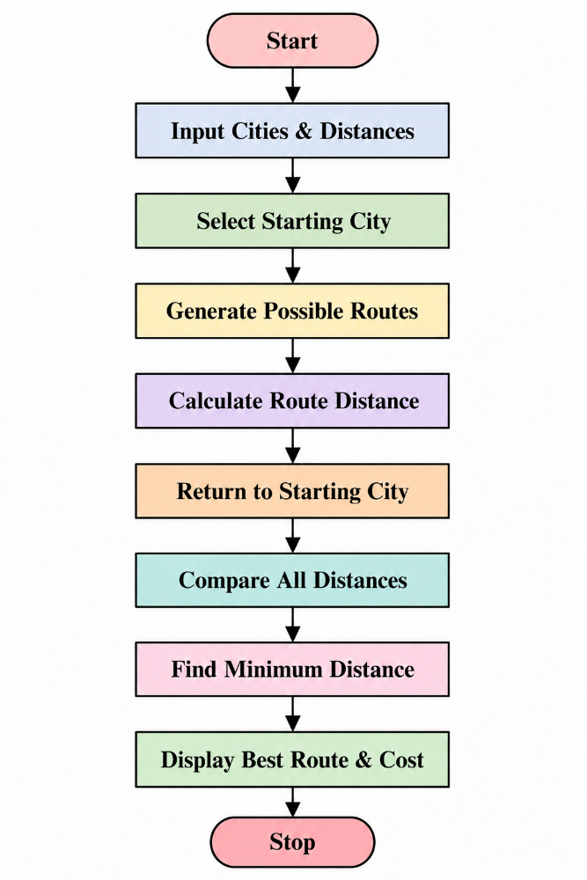
Code
from itertools import permutations

cities = ['A', 'B', 'C', 'D']

distance = {
'A': {'A': 0, 'B': 10, 'C': 15, 'D': 20},
'B': {'A': 10, 'B': 0, 'C': 35, 'D': 25},
'C': {'A': 15, 'B': 35, 'C': 0, 'D': 30},
'D': {'A': 20, 'B': 25, 'C': 30, 'D': 0}
}

start = 'A'
remaining = [city for city in cities if city != start]

min_distance = float('inf')
best_route = None

for route in permutations(remaining):
current_route = (start,) + route + (start,)

total_distance = 0

for i in range(len(current_route) - 1):
total_distance += distance[current_route[i]][current_route[i + 1]]

if total_distance < min_distance:
min_distance = total_distance
best_route = current_route

print("Best Route:", " -> ".join(best_route))
print("Minimum Distance:", min_distance)

Output
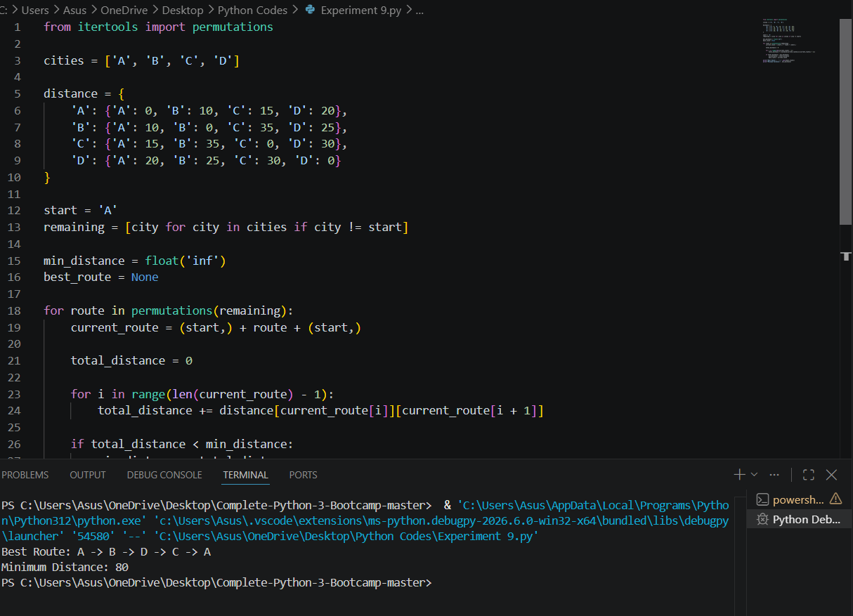

Result
The Travelling Salesman Problem was successfully implemented using Python, and the minimum-cost route was obtained.

Conclusion
The program examines the possible routes and selects the route with the minimum total travelling distance while visiting each city exactly once and returning to the starting city.

